**CHAPTER 4**

**RESULT AND DISCUSSION**

This chapter explains the results and findings throughout this project featuring the

user interfaces and functionality test.

**4.1 Virtual Buddy Application: Chat Management User Interface**

The user's initial experience with a system is through its user interface. It offers an abstraction that conceals the app's complexity and presents a more user-friendly interface.

Figure 4.1 depicts the system's recommender system interface. 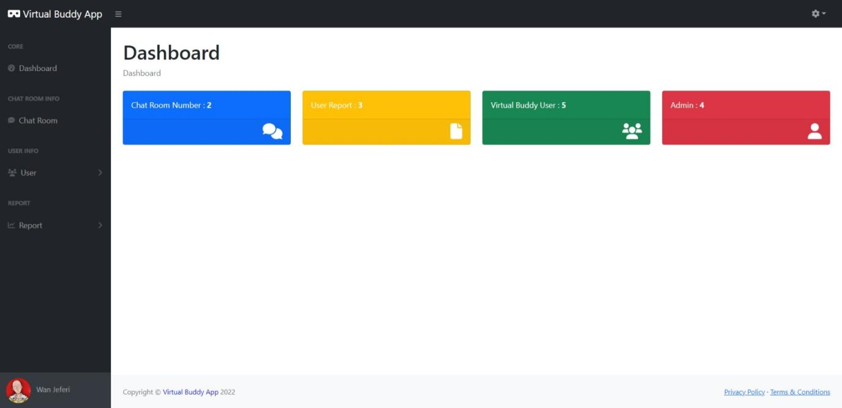

**Figure 4.1** Virtual Buddy Application: Chat Management user interface

**4.2 Functionality Test and Result**

**Table 4.1** Feasibility Studies Framework

|  |  |  |
| --- | --- | --- |
| **Event** | **Expected Outcome** | **Result** |
| To install system as Progressive Web Application (PWA) | * The system will be able to be use as Progressive Web Application | Pass |
| Login | * To check the login function | Pass |
| Reset Password | * The user will be able to reset the password | Pass |
| User Profile Settings Button | * The user will be able to view user profile page | Pass |
| Update Profile Picture | * The user can update their profile picture | Pass |
| Update Personal Information | * The user can update their personal information | Pass |
| Change Password | * User can change the current password with a new one | Pass |
| Admin List Option | * The user will be able to display the admin list content | Pass |
| Add New Admin | * A new admin will be added to the database | Pass |
| Edit Admin | * To update the admin information | Pass |
| Delete Admin | * The selected admin will be deleted | Pass |
| View Admin Info | * The selected info of admin will be displayed | Pass |
| User Report Option | * The system will display the user report information | Pass |
| Ban User | * The selected user will be ban | Pass |
| Unban User | * The selected user will unban | Pass |
| Report Analytic Option | * The system will show the report analytic page | Pass |

**4.2.1 Install Progressive Web Application (PWA)**

The PWA in this system is to enable the user to store the web system in their own device. It generates an icon in the shape of a website application, and when that icon is opened, it feels like a mobile application. Figure 4.2, 4.3, 4.4 and 4.5 is showing how to install the system as PWA and how it will be view as PWA.

Click this icon

**Figure 4.2** Install system as PWA

In the system main page, the user must click the icon as shown in Figure 4.2 to install the PWA.

Click install

**Figure 4.3** Confirm PWA install

Next, in Figure 4.3, the user must click install button to confirm install the system as a PWA.

**Figure 4.4** Virtual Buddy Application: Chat Management PWA Icon

Figure 4.4 show the icon of the system will be shown in the user desktop.

**Figure 4.5** System opened as PWA

Figure 4.5 show that when the icon of the system is clicked, it will open the system as PWA, and the system can be view as mobile applications.

**4.2.2 Login**

**Figure 4.6** Login page

User must enter a valid email address and password to login into the system as shown in Figure 4.6.

**Figure 4.7** Error login message

When the user enters a wrong email or wrong password, the system will prompt an error message to the user and the user must enter a correct email address and password to be able to login to the system as shown in Figure 4.7.

**4.2.3 Reset Password**

Click this link

**Figure 4.8** Reset password

To reset the password, user must click the **Forget Password?** link in login page as shown in Figure 4.8.

**Figure** 4.9 Enter email page

Next, the user must enter the valid email address to enable the system to send a reset link to the email address. By clicking the **Send Password Reset Link** button, the system will send the reset link to the user email address as shown in Figure 4.9.

**Figure 4.10** Successful message

A successful message will be prompt to the user if the email is valid and the reset link is sent to the user as shown in Figure 4.10.

**Figure 4.11** Invalid email error message

An error message will be prompt by the system when the user is entered an invalid email address as shown in Figure 4.11.

Option 2

Option 1

**Figure 4.12** The password reset link

In the user email address, there will be the reset link that has been sent by the system. Users have two options either to click the **Reset your password** button or by copy and paste the link given to be directed to the reset password page as shown in Figure 4.12.

**Figure 4.13** Reset password page

Next, user will be directed to the reset password page. The user needs to enter the new password and confirm password input. By clicking the **Reset Password** button, the user will be directed to the login page as shown in Figure 4.13.

**Figure 4.14** Password confirm error

An error will be prompt when the password and confirm password input does not match as shown in Figure 4.14.

**Figure 4.15** Success reset password

Next, user will be directed to the login page and the system will prompt a successful message state that the password has been changed as shown in Figure 4.15.

**4.2.4 Profile Settings Button**

Click profile button

**Figure 4.16** Profile button

User needs to click the profile button to be directed to the user profile page as shown in Figure 4.16.

**Figure 4.17** User Profile Page

Next, user will be able to display the user profile page. There are several options the user can make such as update profile picture, update personal information, and change password as shown in Figure 4.17.

**4.2.4 Update Profile Picture**

Change picture button

**Figure 4.18** Change picture button

To change the profile picture, click the **Change picture** button as shown in Figure 4.18.

**Figure 4.19** Select picture

When user click on the **Change Picture** button, the system will prompt out the file selection and user must pick a picture to be use as a profile picture as shown in Figure 4.19.

**Figure 4.20** Crop image

Next, user will be able to customize the picture. After that, user must click the **CROP** button to proceed or **EXIT** button to discard as shown in Figure 4.20.

**Figure 4.21** Success message

The system will prompt the success message if the update picture process is success as shown in Figure 4.21.

**Figure 4.22** Update success

The profile picture is successfully updated as shown in Figure 4.22.

**4.2.4 Update Personal Information**

Field in the input

**Figure 4.23** Update Personal Information

To update user personal information, user must field in the information that want to be updated as shown in Figure 4.23.

**Figure 4.24** Personal Information Update Success Message

The system will prompt a success message if the update of personal information is successful as shown in Figure 4.24.

**Figure 4.25** Personal Information Update Success

The personal information of user has been updated as shown in Figure 4.25.

**4.2.5 Change Password**

Change Password Button

**Figure 4.26** Change Password Button

To change the password, user must click the **Change Password** button as shown in Figure 4.26.

**Figure 4.27** Change Password Page

Next, user will be redirected to the change password page. User needs to field all the required fields as shown in Figure 4.27.

**Figure 4.28** Change Password Page Error

There will be some error message will be prompted to the user such as the incorrect of current password and the new password must be at least 8 characters as shown in Figure 4.28.

**Figure 4.29** Success change password message

After successfully changing the password, the system will prompt the success message and the password will be updated as shown in Figure 4.29.

**4.2.6 Admin List Option**

Admin List Option

**Figure 4.30** Admin List Option

To view the admin list content, user needs to select the admin option from sidebar navigation as shown in Figure 4.30.

**Figure 4.31** Admin List Content

Next, the content of the admin list will be view. The user can view the admin information such as name, email, and role as shown in Figure 4.31.

**4.2.6 Add New Admin**

Click Add Button

**Figure 4.32** Add Button

To add new admin, the user needs to click the **Add** button as shown in Figure 4.32.

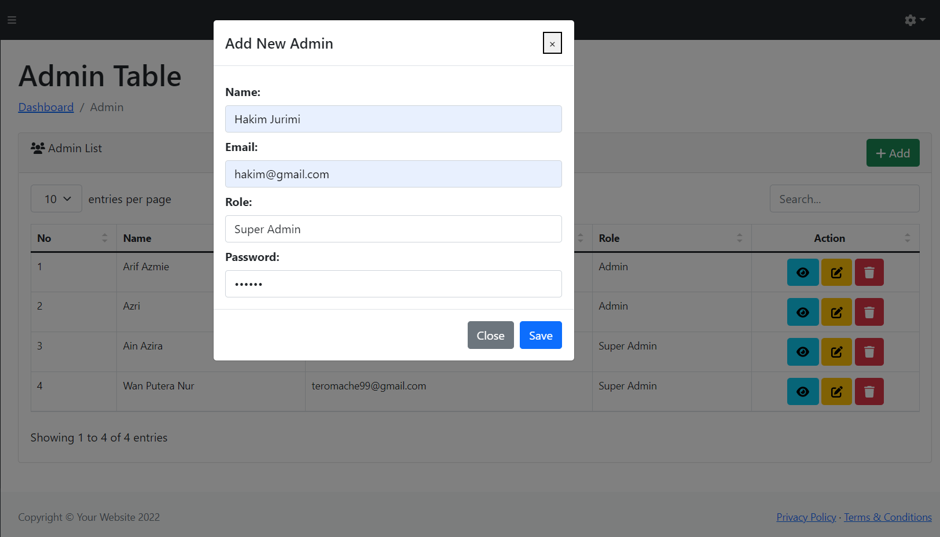

**Figure 4.33** Modal Form of Add New Admin

Next, the system will pop up a modal form to add the new admin. The user needs to fill in all the fields needed as shown in Figure 4.33.

New Admin

Success Message

**Figure 4.34** Success Add Admin

After successfully add new admin, system will prompt a success message and the new admin will be displayed as shown in Figure 4.34.

**4.2.6 Edit Admin**

Edit Button

**Figure 4.35** Edit Admin Button

To edit the admin information, user needs to click the yellow edit button as shown in Figure 4.35.

**Figure 4.36** Edit Admin Modal Form

Next, modal form will be pop up and the user needs to enter all the input needed as shown in Figure 4. 36.

Success Message

Admin Edited

**Figure 4.37** Success Edit Admin

Figure 4.37 shows the success message when the update is successful, and the admin will be edited.

**4.2.6 Delete Admin**

Delete Button

**Figure 4.38** Delete Admin Button

To delete the admin, click the delete button as shown in Figure 4.38.

**Figure 4.39** Confirm Delete Message

Next, the system will prompt a confirm message either to delete the admin or not. To proceed, the user must click the **DELETE** button or click **CANCEL** button to revoke the operation as shown in Figure 4.39.

Delete Message

**Figure 4.40** Delete Admin Success

After the delete admin process is successful, there will be a message indicate that the admin has been deleted as shown in Figure 4.40.

**4.2.7 View Admin Info**

Info Button

**Figure 4.41** View Admin Info Button

To view the admin information, the user needs to click the blue button as shown in Figure 4.41.

**Figure 4.42** Admin Information

The selected admin information will be displayed. The user can click the **CLOSE** button to close the modal form as shown in Figure 4.42.

**4.2.8 User Report Option**

User Report Option

**Figure 4.43** User Report Option

Figure 4.43 shows the user report option. To view this option, user needs to click the **Report** option and then the **User Report** option will be displayed. Next, user needs to click on that option to display the content of the user report.

**Figure 4.44** User Report Content

Figure 4.44 shows the user report content. There is some information viewed here such as the offender’s name, the offender email, and the status to indicate either the report is not having an action been taken or it already has been taken an action on it. The **Details** button will be redirect to the report detail.

Ban User

**4.2.9 Ban User**

**Figure 4.45** Ban User Content

Figure 4.45 shows the page that will appear after clicking the **Details** button in user report page. In this page, the list of reporter name will be displayed based on the selected offender. There is also report type that the reporter makes to the offender. To ban the offender, user need to click to the **Ban** button.

**Figure 4.46** Ban Confirmation

Figure 4.46 shows the prompt message that will be send by system to confirm the banning process. Click the **Proceed** button to confirm the ban process or **Cancel** button to cancel it.

**Figure 4.47** Ban Success

After the banning process is success, it will redirect back to the User Report page and will show the success message as shown in Figure 4.47. The status of the report is also change where before this it is shown that there is **No action taken**, but after the banning process has been done, the status has changed to **User Banned.**

List of inappropriate activity

Number of report

**Figure 4.48** Report Email

Figure 4.48 shows the report email content. This email will be sent to the offender email after the banning process is done. In this email, the offender will be provided with the number of users that report him and the list of inappropriate things that the offender has been done.

**4.2.10 Unban User**

Unban User Button

**Figure 4.49** Report Email

To unban user, click the **Unban User** button in the Report Detail page as show in Figure 4.49.

**Figure 4.50** Unban Confirm Message

Next, there will be a confirmation modal will pop up. If the user wants to proceed to unban the offender, user must click on **Proceed** button or click **Cancel** button to cancel the process as show in Figure 4.50.

**Figure 4.51** Unban Success

After the unban, process is successful, the user will be redirected to the User Report page and there will be a success message appear in the top of the page. The offender information also has been removed from the User Report list as shown in Figure 4.51.

**Figure 4.52** Unban Email

The offender also will receive an email indicating that he or she has been unban as shown in Figure 4.52.

**4.2.11 Report Analytics**

Print button

**Figure 4.53** Report Analytic Page

Figure 4.53 shows the report analytics of the system. First, the area chart indicates the number of users that register to the system for each month. The pie chart on the left indicates the percentage of report base on each report type which is body shamming, abusive word, and fake news. The pie chart on the right indicates the percentage of user most used keyword. The page also can be printed by clicking the **Print** button.

**4.3. Main Function Code**

**4.3.1 Ban User Code**

public function ban_user(Request $request)

    {

        $offender_email = $request->get('offender_email');

        $status = Report::where('offenders_email',$offender_email)->update(['status'=>true]);

        $count = Report::select('reporter_username')->where("offenders_email","=",$offender_email)->count();

        $report_type = Report::select('report_type')->where("offenders_email","=",$offender_email)->get();//array

        $user= VBUser::where('email',$offender_email)->update(['isBan'=>true]);

        $body = "";

        //send report email to user

        $body .= "We are received <b>".$count." report</b> for account associated with ".$offender_email.". You will be ban from using the Virtual Buddy App for certain time because you have been reported for doing an inapropriate activity in the chat base on the list below. For more enquiries please email us at virtualmanagement2022@gmail.com or call us at <i>09-91939495.</i> <br><br> <b>List of inapropriate activity</b> <br>";//msg

        $no = 1;

        foreach($report_type as $data)

        {

            $body .= $no.".".$data->report_type ."<br>";

            $no++;

        }

        \Mail::send('layouts.email-ban',['body'=>$body], function($message) use($offender_email){

            $message->from('virtualmanagement2022@gmail.com','Virtual Buddy App');

            $message->to($offender_email)

                    ->subject('Ban Report');

        });

        return redirect('/user_report')->with('success','User has been succesfully ban');

    }

The above code is the controller code use to ban the user. The Laravel framework is used to code this coding. First the controller will request the offender email from the blade file form. Next, the $status variable is indicated to the update process of the report status. It will check the offender email that requested from the blade file form with the email in the user table from database. If the email is found, it will update the status to Boolean data true. Boolean true means that the report has been taken an action on it and otherwise if the Boolean data is false. The $count variable is used to count the number of reporters that make a report toward the offender. From the report table, all the data will be selected where the offender email from blade file form is equal to email from the report table in the database. Then, the count () function is used to count the selection. The $report_type variable is used to select the report that has been done toward the offender. It will get the report_type variable from the Report table in database base on the where collection that check the offenders email variable form blade file form and compare it with the offender email from the Report table in database. The get () function is used to get the array of the selection data. To update the user status in User table, the $user variable is used. It will check the email from the User table and compare it with the offender email from the blade file form. If the email is founded, then the user isBan status will be updated to true. True indicate that the user is banned. The $body variable is the content of the email that will be sent to the user and the foreach loop also will be use for the content of the email. To send email to the offender, the Mail::send function is used. The “$message->from ('virtualmanagement2022@gmail.com','Virtual Buddy App');” line of code indicates the email address of the sender and $message->to($offender_email)->subject('Ban Report');” line of codes indicates to whom the email will be send which is to the offender. The offender email variable that is get from the blade file form is use in this function to get the offender email address.

**4.4 Discussion**

While this programme was being developed, there were some problems and difficulties. The main problems in developing Virtual Buddy Applications: Chat Management System is the database. In this system, the MongoDB were use because this system will be merge with the front-end system, Virtual Buddy Applications: Chat Room that used MongoDB as its database. The issue with it is that MongoDB's entire purpose is to avoid having relationships between tables. To make a relationship with the front-end system table is hard. The easiest way to have a relation between table is actually using the MySQL database.

**4.5 Summary**

The phases of development and testing have been covered in this chapter. The Progressive Web Application (PWA) is used in this system to give the system the ability to be displayed in mobile form view and the icon for the system can be create using the PWA. The Laravel framework is used to develop this system. The Laravel framework will help to make the development process become easier and faster. Functionality and validation have been performed during the testing phase to ensure that the application functions correctly and is error-free.